Performing Operating System Recovery

|  |
| --- |
| PRELIMINARY  CCpilot XM and CrossCore XM |

|  |  |
| --- | --- |
| cc.jpg | http://intranet/processes/products/Product%20pictures/CCpilotXM_front%20left_gfx_midres.jpg |
| www.crosscontrol.com |

Contents

Revision history 2

1. Introduction 3

1.1. Conventions and defines 3

1.2. Identification 3

1.3. References 3

2. Why do a recovery 4

2.1. Recovery basics 4

2.2. Secondary boot media 4

2.3. Recovery pre-requisites 4

3. ImageToDisk program 5

3.1. Installation 5

3.2. Running ImageToDisk 8

4. Performing the recovery 11

4.1. BIOS boot menu 11

4.2. Booting recovery system 11

4.3. Trigger recovery 12

Technical support 13

Trade Mark, etc. 13

# Revision history

|  |  |  |
| --- | --- | --- |
| Rev | Date | Comments |
| 1.0 | 2012-05-24 | - |
| 1.1 | 2012-11-27 | Update with CrossCore/A-I information |

# Introduction

This guide shows you how to create a recovery USB memory that can be used for operating system recovery on the XM devices. It also covers the instructions for the recovery process.

## Conventions and defines

CCpilot XM and CrossCore XM are in most cases identical in functionality and usage. The following definition is used to separate unit specific details. The observe symbol is also used to highlight such difference.

|  |  |
| --- | --- |
| Defines | Use |
| CCpilot XM | Information that is specific for CCpilot XM |
| CrossCore XM | Information that is specific for CrossCore XM |
| XM device | Information that applies to both CCpilot XM and CrossCore XM |



The observe symbol is used to highligt information in this document, such as differences between product CCpilot and CrossCore product models.

The A symbol is used to highlight information specific for CCpilot XM and CrossCore XM All-Integrated.

The exclamation symbol is used to highlight important information.

Text formats used in this document.

|  |  |
| --- | --- |
| Format | Use |
| *Italics* | Paths, filenames, definitions. |
| **Bolded** | Command names and important information |

## Identification

On the side of the XM device there is a label. On the label there are version and serial numbers which identify your unique computer. Take note of them. During service and other contact with the supplier it is important to be able to provide these numbers.

## References

For further information on the XM device see the following references.

1. CCpilot XM and CrossCore XM – Software Guide
2. CCpilot XM and CrossCore XM – Technical Manual

# Why do a recovery

## Recovery basics

The operating system is installed on the removable Compact Flash disk inside the device. It acts as a typical computer hard drive, storing the operating system files in a file system architecture. In some rare cases, such as when an operating system update was unintentionally interrupted by a sudden power loss, or if specific changes were done to the operating system that cannot be undone, a full operating system recovery may need to be done.

It is also possible to perform the recovery steps to be able to install a newer operating system from scratch, if so chosen.

A recovery operation will erase all contents on the Compact Flash. If there is a need to save any data from the device, make sure it’s done prior to the recovery operation begins.

## Secondary boot media

A recovery cannot be done from within a running system, since it cannot overwrite itself while it’s running. So there will be a need for a secondary bootable system and the XM device supports booting from USB memory. The following section will explain how to create such a memory that contains the recovery binaries.

## Recovery pre-requisites

A recovery operation needs a couple of items available before the actual work can begin. First, make sure that you have:

* Host PC computer running Windows XP or later.
* USB memory, at least 4 GB in size. It must support booting from it. USB memory quality also tends to differ a lot between different manufacturers, so if one USB memory doesn’t work properly, try a different brand first hand.
* Downloaded the correct recovery image from CrossControl customer site (FTP), there are different ones for each operating system. Choose one of the following:
  + *RecoveryUSB_XM_Linux_x.x.x.x.img.zip*
  + *RecoveryUSB_XM_WES7_x.x.x.x.img.zip*
  + *RecoveryUSB_XM_WinXP_x.x.x.x.img.zip*

The operating system image version affects the Recovery USB image versions, and hence only the latest versions will be available as above. Note that these are not XM device Compact Flash images, these are USB memory images.

* Download the Windows based helper tool called ImageToDisk, located on FTP site in parallel with the recovery images.
* A recovery object, XM device with:
  + USB keyboard attached
  + Free USB connection for the USB memory mentioned above.

It is possible to use a USB hub to connect these to the XM device.

# ImageToDisk program

CrossControl has developed a simple tool that enables reading and writing image files from and to different removable storage media. This is a short guide to that program, which is called ImageToDisk.

## Installation

The installation package is an executable installer, *ImageToDisk.exe*, which is aimed for installation in a host PC computer running Windows XP or later, not the target XM device. Double click that executable to start the installation process. If User Access Control asks, please allow the installer to run. You should now see the following dialog: 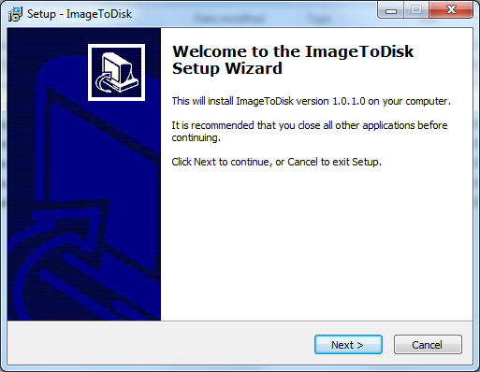

Press the next button.

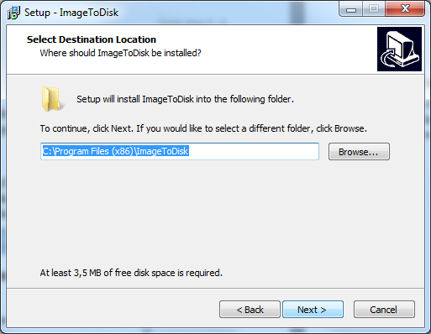

Choose your preferred installation directory and press next.

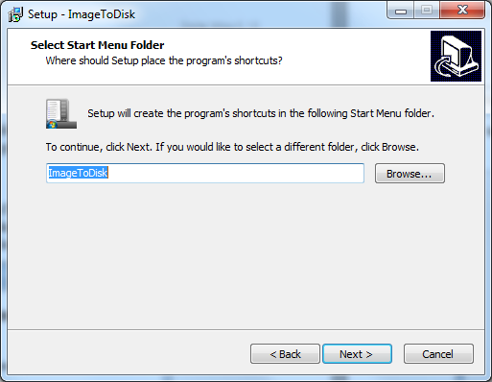

Choose the shortcut name and press next.

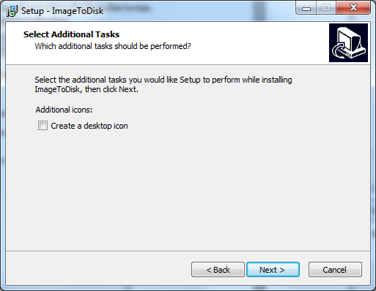

Determine if you want a desktop icon or not, and press next.

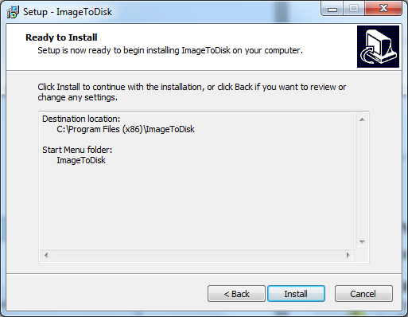

It’s now ready to install, press Install.

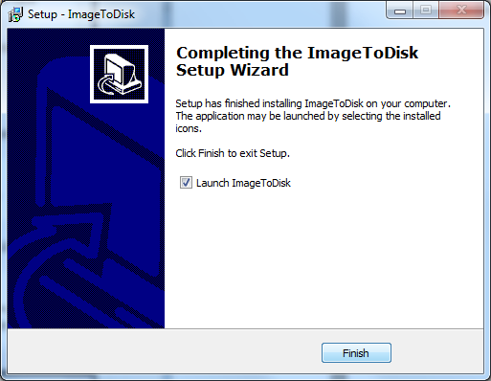

Installation is finished, now ImageToDisk can be run.

## Running ImageToDisk

Once the ImageToDisk program is running, you should be able to see the following dialog box:

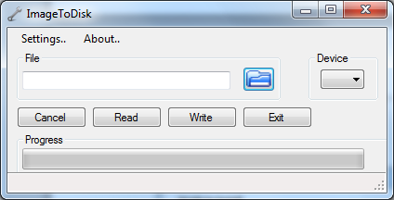

If you get an error when starting ImageToDisk, similar to this one:

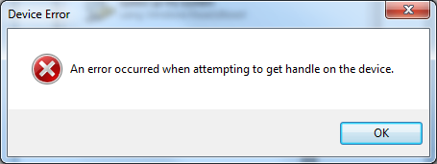

This could mean that you need to start ImageToDisk in administrator mode. The above error means it cannot access the USB device properly unless run as an administrator.

Exit ImageToDisk if it is running and right-click on its installed executable, and choose Run as administrator, as seen below:

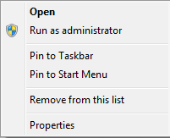

Now, ImageToDisk should be running properly. If the USB memory hasn’t been inserted to host computer yet, now is the time to do that.

If the USB memory is inserted, you will see the device name in the device field of ImageToDisk. In the example below, the USB memory is identified as F:.

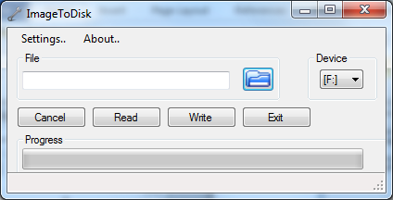

Please note that you must carefully choose the correct device (USB memory), and you must also be aware that the ImageToDisk program will erase the entire USB memory. It is also required that the USB memory is at least 4 GB in size.

### Finding image file

ImageToDisk needs to find the image file to write to the USB memory. You should choose the corresponding one from section 2.3, and additionally make sure that the image file is in one of the two following formats: *img.gz or *.img. If the image is in .zip format, it needs to be decompressed to a proper *.img file.

Then, press the Open folder icon in the ImageToDisk program, browse for the image file you will use, choose it and press Open.

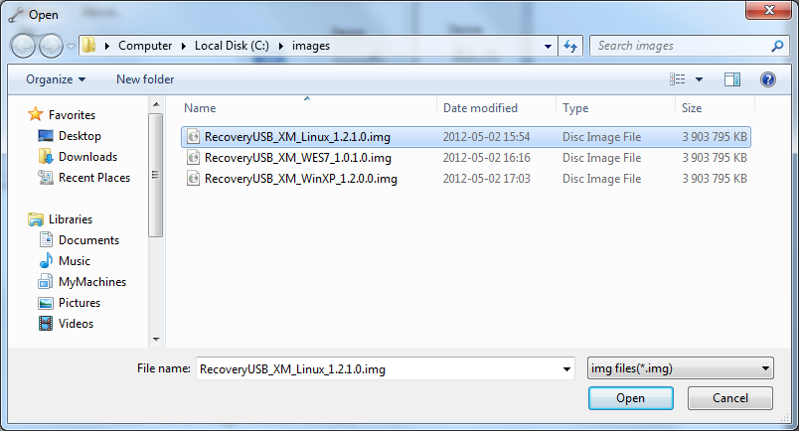

You should now have a ImageToDisk program that looks like:

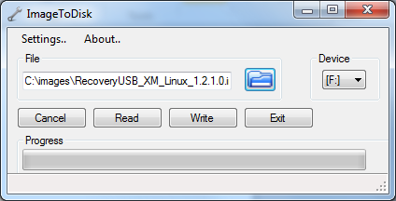

### Write image to USB memory

To write the image to the USB memory, you now just need to press the Write button. The write process begins, and takes a couple of minutes, depending on the speed of the actual USB memory.

You will need to confirm the write operation with:

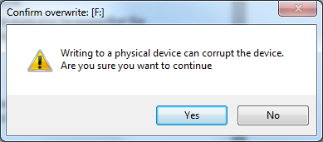

When allowing the write operation you should see the program as this, with a progress indicator increasing:

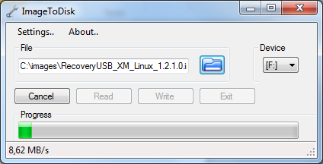

Once the write operation finished, remove the USB memory from the host computer in ordinary manner, and insert it to the XM device setup. The ImageToDisk program will simply return to its standard interface when finished.

# Performing the recovery

Let’s now shift focus to the XM device. Insert the USB memory we’ve just written to the available USB port of the XM device. It is possible to use a USB hub.

## BIOS boot menu

Power up the XM device and press the ***F11***key at a certain point in the initial execution, to trigger the BIOS boot menu to appear. This key should be pressed as soon as the BIOS show its initial text Once the BIOS boot menu appears, there should be a list of bootable devices to choose from. If only one USB memory is attached, the only two choices should be the internal hard drive (HDD) and the USB memory. Browse with arrow keys and choose the USB memory with Enter/Return key, and let the system startup.

Since CrossCore XM does not have a display, booting of the USB stick has to be performed blindly. For these steps to work, it is important that only one USB memory is attached (the recovery USB memory). Follow these steps:

* Make sure that the USB memory has a file called autoload.txt (see section 4.3)
* After powering up CrossCore XM, repeatedly press the F11 key for about 15-20 seconds.
* Wait 5 seconds and then press the Down arrow key once.
* Finally press the Enter key.

## Booting recovery system

The recovery system is a small Linux system that runs from the USB memory. It will start a graphical system by default, and it will also display some boot progress indicators while starting.

Once started, a small instruction dialog appears, as well as a command window, as seen below:

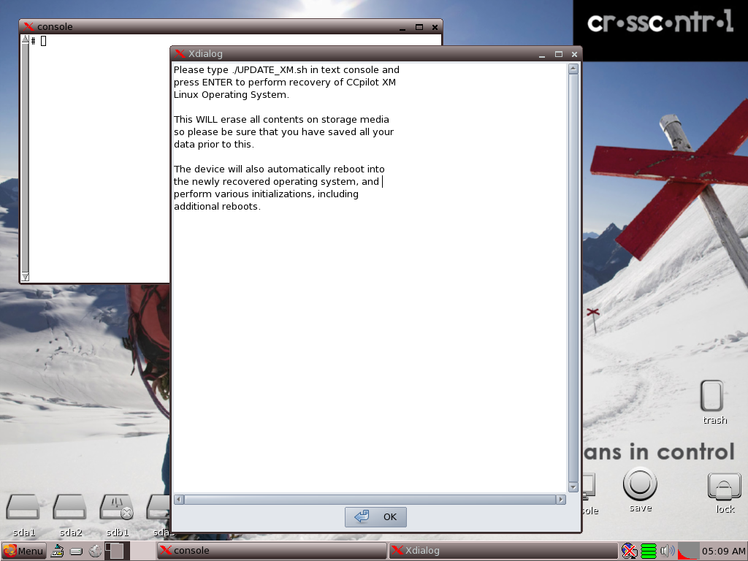

## Trigger recovery

Read the instructions in the dialog and press the OK button when finished. Then write the command (as in the instructions)

**# ./UPDATE_XM.sh**

Press Enter/Return key, and the recovery process begins. You should see a screen that looks something like:

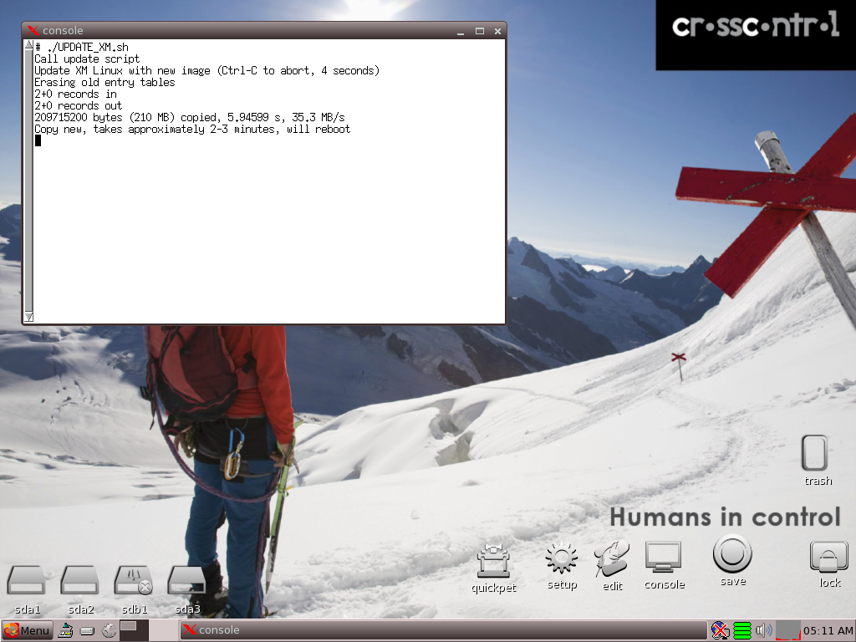

After the recovery completes, the XM device will reboot itself and begin operating system initialization processes. The actual initialization process can take several minutes and involves automatic reboots, so please keep the device powered until the initialization process is finalized.

Now, the XM device operating system should be fully recovered and you can start deploying your software!

For CrossCore XM, the USB memory must be prepared to execute the update without user interaction. This is done by placing a text file (it can be empty) on the USB memory. The text file must be called “autoload.txt”. The Linux system is configured to automatically execute the UPDATE_XM.sh script when this file exists.

The update may take 5-20 minutes (time varies depending on which OS is being restored). The LED on the unit may turn green for a while, and then start blinking yellow again. This is due to the above mentioned automatic restarts of the recovery process. When the LED turns green a second time, it is safe to log on to the unit with ssh or VNC for further configuration.

# Technical support

Contact your reseller or supplier for help with possible problems with your XM device. In order to get the best help, you should have access to your XM device and be prepared with the following information before you contact support.

* The part number and serial number of the device, which you find on the brand label.
* Date of purchase, which is found on the invoice.
* The conditions and circumstances under which the problem arises.
* LED indicator flash patterns.
* Prepare a system report on the device, from within *CCsettings* (if possible).
* Detailed description of all external equipment connected to the unit (when relevant to the problem).

# Trade Mark, etc.

© 2012 CrossControl AB

All trademarks sighted in this document are the property of their respective owners.

CCpilot is a trademark which is the property of CrossControl AB.

Intel is a registered trademark which is the property of Intel Corporation in the USA and/or other countries. Linux is a registered trademark of Linus Torvalds. Microsoft and Windows are registered trademarks which belong to Microsoft Corporation in the USA and/or other countries.

CrossControl AB is not responsible for editing errors, technical errors or for material which has been omitted in this document. CrossControl is not responsible for unintentional damage or for damage which occurs as a result of supplying, handling or using of this material including the devices and software referred to herein. The information in this handbook is supplied without any guarantees and can change without prior notification.

For CrossControl licensed software, CrossControl AB grants you a license, to under CrossControls intellectual property rights, to use, reproduce, distribute, market and sell the software, only as a part of or integrated within, the devices for which this documentation concerns. Any other usage, such as, but not limited to, reproduction, distribution, marketing, sales and reverse engineer of this documentation, licensed software source code or any other affiliated material may not be performed without written consent of CrossControl AB.

CrossControl respects the intellectual property of others, and we ask our users to do the same. Where software based on CrossControl software or products is distributed, the software may only be distributed in accordance with the terms and conditions provided by the reproduced licensors.

For end-user license agreements (EULAs), copyright notices, conditions, and disclaimers, regarding certain third-party components used in the XM device, refer to the copyright notices documentation.